**E-COMMERCE SALES ANALYSIS**

A Project Report

submitted in partial fulfillment of the requirements

of

……………. Track Name ……

by

**Name of Student: M.Dharunesh**

**Email id: tharunesh144@gmail.com**

**NM Id: 1A528C12003DF89BC854234C2716AA65**

Under the Guidance of

**(P.Raja, Master Trainer, Edunet Foundation)**

**ACKNOWLEDGEMENT**

We would like to take this opportunity to express our deep sense of gratitude to all individuals who helped us directly or indirectly during this thesis work.

I am really grateful and wish my profound indebtedness to Supervisor P.RAJA Deep Knowledge & keen interest of my supervisor in the field of Machine Learning to carry out this project. His endless patience, scholarly guidance, continual encouragement, constant and energetic supervision, constructive criticism, valuable advice, reading many inferior drafts and correcting them at all stages have made it possible to complete this project.

I would like to express my heartiest gratitude to Mohamed Azarudheen, Department of MECHANICAL, for his kind help to finish my project.

I would also generously welcome each one of those individuals who have helped me straightforwardly or in a roundabout way in making this project a win. In this unique situation, I might want to thank the various staff individuals, both educating and non-instructing, which have developed their convenient help and facilitated my undertaking.

Finally, I must acknowledge with due respect the constant support and patients of my parents.

DHARUNESH M

**ABSTRACT**

This dissertation was written as a part of the MSc in e-Business, Innovation & Entrepreneurship of the International Hellenic University, and was conducted in cooperation with iTrust.gr, which is an Internet marketing agency offering holistic digital solutions, based in Thessaloniki. The thesis has dealt with the subject of “A novel digital marketing approach for the Conversion Rate Optimization for e-Commerce in the fashion and beauty sectors”.

The aim of this thesis is to develop a guideline of best practices on some key factors that affect Conversion Rate Optimization and touch upon Online User Behavior. The dissertation firstly approaches some key metrics that are used in terms of measuring the usability of an e-shop, and the techniques and methods that are being used in order to implement conversion goals of e-commerce companies. At the same time, some best practices that are being used by leaders in the market are also hereby examined.

The empirical part of the thesis was conducted with a questionnaire-based survey, that had as a goal to define the e-shops’ users opinion and point of view towards some key factors and elements of the e-shops, that affect its performance on key conversion metrics.

At this point, I would also like to thank all those who contributed to the completion of this thesis, such as my family, my friends, my supervisor Dr. Christos Berberidis, and the people at iTrust.gr, who gave me guidance and useful advice on my dissertation, and of course, all those who took part in my survey and helped me complete the research.

E-commerce is widely considered the buying and selling of products over the internet, but any transaction that is completed solely through electronic measures can be considered e-commerce. E-commerce is subdivided into three categories: business to business or B2B (Cisco), business to consumer or B2C (Amazon), and consumer to consumer or C2C (eBay). also called electronic commerce. M-commerce is a term that is used to refer to the growing practice of conducting financial and promotional activities with the use of a wireless handheld device.

The term m-commerce is short for mobile commerce, and recognizes that the transactions may be conducted using cell phones, personal digital assistants and other hand held devices that have operate with Internet access. E-commerce Security is a part of the Information Security framework and is specifically applied to the components that affect e-commerce that include Computer Security, Data security and other wider realms of the Information Security framework. E-commerce security has its own particular nuances and is one of the highest visible security components that affect the end user through their daily payment interaction with business.

**TABLE OF CONTENTS**

Abstract 3

List of Figures 4

List of Tables 5

**Chapter 1.**  **Introduction**

1.1 Problem Statement

1.2 Motivation

1.3 Objectives

1.4. Scope of the Project

**Chapter 2.**  **Literature Survey**

**Chapter 3.**  **Proposed Methodology**

**Chapter 4.**  **Implementation and Results**

**Chapter 5. Discussion and Conclusion**

**References**

**LIST OF FIGURES**

|  |  |  |
| --- | --- | --- |
| **Figure No** | **Name of the Figure** | **Page No.** |
|  | Conversion Funnel, Andrew King, Website Optimization, 2008 | **10** |
|  | Brian Clifton | **12** |
|  | Brian Clifton Advanced web metrics with google analytics | **13** |
|  | E-Commerce Bench& Retail Report 2016 | **13** |
|  | E-Commerce Bench& Retail Report 2016 | **17** |
|  | Gender Of Participants | **18** |
|  | Age of Participants | **18** |
|  | Women Age | **19** |
|  | Men Age | **19** |
|  | Frequency Of Using The Internet | **20** |
|  | Device Used For Online Shopping | **21** |

**CHAPTER 1**

**INTRODUCTION**

* 1. **Problem Statement:** Despite the fact that Conversion Rate Optimization is a topic that has been dealt with for quite some years now, according to Owen (2010), many businesses still falter when it comes to converting traffic into sales. Geoff Galat (2011), Vice President of marketing at Tealeaf, claimed that marketing professionals are stuck at a 92:1 ratio - 92£ are -3- being spent driving traffic to the company’s website and only 1£ is spent on working with conversions. This points out that there is a significant gap in the priorities of the companies’ online marketing strategies and budgets. Some main challenges, especially for companies operating in the fashion and beauty sectors are: ➢ Identifying and selecting the right analytics data to extract in order to proceed with the Conversion Optimization of their websites, ➢ Identifying the most valuable pages of their websites to be optimized. Moreover, some more specific challenges are: ➢ How to lower the exit rate/bounce rate and the cart abandonment rate (terms that are going to be presented at the next chapter), ➢ How to increase the conversion rate, ➢ How to increase ROI of the company’s marketing campaigns, ➢ How to re-engage visitors in the conversion funnel. All these challenges lead to one major question which is: Which are the most efficient tools to use in order to maximize a website’s Conversion Rate.

The e-commerce industry, especially within the fashion and beauty sectors, faces unique challenges in driving customer engagement, increasing conversion rates, and fostering brand loyalty in a highly competitive landscape. While these sectors thrive on visual appeal, fast-changing trends, and personalized customer experiences, many e-commerce platforms struggle to optimize their conversion rates effectively. Current digital marketing strategies often lack the tailored, data-driven insights necessary to capture and convert visitors into loyal customers efficiently.

* 1. **MOTIVATION:** In the competitive landscape of fashion and beauty e-commerce, conversion rate optimization (CRO) is essential for turning visitor interest into actual purchases. Traditional digital marketing techniques, though effective in driving traffic, often fall short in transforming visitors into loyal customers. This creates an opportunity for a fresh approach to digital marketing tailored specifically to the unique needs and behaviors of fashion and beauty consumers.

Customers in these sectors expect highly personalized, visually engaging shopping experiences that align with their aesthetic tastes and personal values. By using advanced data analytics, predictive marketing, and personalized content, brands can create a more immersive, targeted experience that resonates on a deeper level. Additionally, integrating social proof, such as user-generated content and influencer partnerships, can build community trust and encourage engagement, making customers more likely to complete a purchase.

A mobile-optimized, seamless shopping journey is crucial as well, especially given the dominance of mobile browsing in e-commerce. Moreover, with growing consumer demand for sustainability, brands that emphasize ethical practices and transparent sourcing can foster loyalty among values-driven shoppers. In summary, a novel, CRO-focused digital marketing strategy tailored to these motivators can not only improve conversion rates but also build lasting customer relationships and drive sustainable growth.

High Customer Expectations for Personalization and Experience: Customers in the fashion and beauty sectors seek highly personalized experiences. They expect brands to understand their unique style preferences, beauty needs, and lifestyle choices. Leveraging data-driven insights and AI-powered recommendations can tailor the shopping experience, improving the likelihood of conversion.

Visual Appeal and Aesthetic Sensitivity: Fashion and beauty are inherently visual sectors, and customers are deeply influenced by aesthetics. A CRO-focused marketing approach that prioritizes visually appealing content, such as high-quality images, interactive media, and AR/VR technologies for virtual try-ons, can captivate customers, creating an emotional connection that encourages conversion.

1.3**OBJECTIVES:** The primary objective of a novel digital marketing approach focused on conversion rate optimization (CRO) for fashion and beauty e-commerce is to create a highly personalized, seamless, and visually engaging shopping experience that increases the likelihood of purchase and customer retention. One core goal is to leverage advanced data analytics and artificial intelligence to gain insights into customer preferences, allowing brands to deliver tailored product recommendations, targeted promotions, and customized content. This personalized touch aims to connect with customers on an individual level, addressing their unique tastes and needs, ultimately fostering brand loyalty and increasing repeat purchases.

Another objective is to enhance the visual appeal of the online shopping journey, capitalizing on the inherently aesthetic nature of fashion and beauty. This involves incorporating high-quality images, videos, and interactive media, as well as utilizing augmented reality (AR) and virtual try-on tools that let customers visualize products, creating a more immersive experience. Additionally, integrating social proof—such as user-generated content, reviews, and influencer endorsements—can build trust and create a sense of community, which encourages hesitant shoppers to make a purchase.

Optimizing the mobile shopping experience is also critical, as a growing number of consumers prefer mobile devices for online shopping. This objective focuses on ensuring fast-loading, responsive mobile pages, streamlined navigation, and easy checkouts, reducing friction in the purchase process and leading to higher conversions. Furthermore, a key objective is to highlight the brand’s commitment to sustainability and ethical practices, appealing to modern consumers who prioritize values like eco-consciousness and transparency. By aligning with these customer values, brands can strengthen their appeal and create a loyal customer base. Together, these objectives not only aim to increase conversion rates but also build a foundation for long-term customer engagement and sustainable business growth.

1.4**SCOPE OF THE PROJECT:** The scope of a novel digital marketing approach for conversion rate optimization (CRO) in fashion and beauty e-commerce encompasses a multi-faceted strategy that targets key areas of the customer journey, from discovery to purchase and beyond. This approach will involve leveraging data-driven insights and advanced technologies, such as artificial intelligence (AI) and machine learning (ML), to analyze consumer behavior and preferences. By incorporating these insights, brands can develop highly personalized marketing content, product recommendations, and dynamic pricing strategies that resonate with individual shoppers. This personalization extends across channels, including email marketing, social media, and on-site experiences, creating a seamless omnichannel strategy that aligns with customers’ preferences and behaviors.

Furthermore, the approach will include enhancing visual and interactive elements that cater to the aesthetic and experiential needs of fashion and beauty consumers. This entails optimizing product photography, incorporating interactive videos, and using augmented reality (AR) for virtual try-ons, allowing customers to “try” products from home. These interactive tools will be especially valuable in addressing one of the biggest challenges in online shopping for fashion and beauty—visualizing how products will look in real life.

In addition, the scope includes social proof strategies, such as incorporating user-generated content, customer reviews, and influencer collaborations into the digital marketing mix. These elements will be displayed prominently across the e-commerce site and social media platforms to build trust and community, which are crucial in influencing purchasing decisions in the fashion and beauty sectors. The approach will also include optimizing the mobile shopping experience, given the high percentage of mobile users in these industries, by focusing on fast-loading pages, user-friendly navigation, and simple checkout processes to reduce abandonment rates.

**CHAPTER 2**

**LITERATURE SURVEY**

In order to illustrate the importance of CRO, we can refer to Econsultancy’s seventh Conversion Rate Optimization Report, in association with RedEye for the year 2015, where 90% of the participating marketers in the survey characterized CRO as Important and Crucial to their overall digital marketing strategy, and only 1% believe it to be of no importance. In the following chapter we are going to examine in more detail some basic elements of the discussion around the Conversion Rate Optimization in e-commerce.

**2.1 Conversion Funnel**

According to Eisenberg (2009), “the sales process is about moving consumers along a path that goes from prospecting to close to retention. In the sales process, you appear to have much more control of the customer’s environment. You can optimize clearly defined steps that move prospects forward to a close”. Also, the Conversion Funnel is defined by Andrew B. King (2008) as “a path that a visitor takes from entering your website to the point where the visitor becomes a conversion in the form of a sale or lead”. This sales process of an e-commerce website can be very usefully depicted and visualized through a Conversion Funnel. It is a good way to illustrate the effect of changes being done on the increase of the conversion rate. It is a well-defined process (most usually pages) leading to a conversion goal, for example, a check-out system (Clifton, 2010). A typical sales conversion funnel may look like the one in the following figure (see Figure 1). The conversion funnel consists of some micro-conversion goals which are actually some “steps” that the users have to take, in order to complete the ultimate macro-conversion goal, which may be – in the case of an e-commerce site – the purchase of a product.

The intermediate stages of the Conversion Funnel in the case of the Figure 1 can be described as following. First of all, the website gets a certain number of visitors.

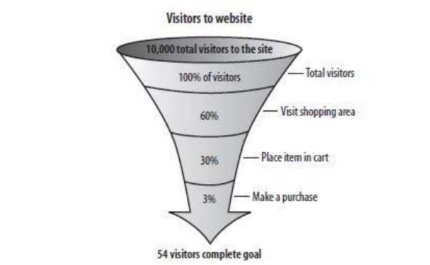

Figure 1: Conversion Funnel, Andrew King, Website Optimization, 2008

At the next stage, some of them will continue browsing through the product categories’ and the products’ pages, while some others will be leaving at that stage. Some of the users who are still online, will be placing an item in their cart, and start the registration/sign-in process. At that stage, also, some users may leave the site, while others will continue. At the final stage of the funnel, we are left with the percentage of visitors who will have taken the desired action, which in the case of an e-commerce website, is the product purchase. By examining the various pages that are included in the conversion funnel’s stages, a company can recognize the points that need to be further optimized, by looking, for example, at pages that have the highest exit rate, an issue which we are going to see in detail later.

2.2 **CRO Metrics & Indicators**

In this section of the chapter we are going to see some important metrics and indicators when it comes to the optimization of an e-shop’s Conversion Rate. According to Avinash Kaushik (2010), “a Metric is a quantitative measurement of statistics describing events or trends on a website”.

2.2.1 **Bounce Rate**

The Bounce Rate is considered one of the most important KPIs that can be taken into consideration during a website’s optimization. As Andrew B. King (2008) defines it, it is the percentage of users who leave a website without browsing to another page, or terminating by some means within a certain period of time. According to Brian Clifton (2010), a bounce is a one-page, zero-action visit, which means that a visitor arrives on your website, views one page, has no further action, and then bounces off to another site or closes their browser.

The aforementioned KPI is a very important and easily understandable KPI that every stakeholder wishes to reduce. Bounced visitors have no value to a business and their number is important to be minimized, in order to maximize revenues. It is a simple metric that can be very illustrative for web performance. There are many different calculation formulas available online for the bounce rate, so in Figure 2 I provide you with the formula given by Brian Clifton: Figure 2. Brian Clifton:

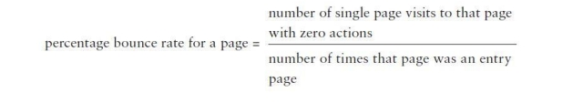

Advanced Web Metrics with Google Analytics™, 2010.

A high percentage of bounced visitors means poor engagement, thus pages with high bounce rates need to be monitored and examined even closer for improvements of content or technical impediments.

Brian Clifton used a traffic-light system in order to categorize the pages of a website and prioritize the necessary actions, depending on each page’s bounce rate, as described in Figure 3.High bounce rate pages (red, bigger than 50%) definitely have to be prioritized for review. There may be an out-of-date content or there may also be errors in the page. If finding the reason for the visitors’ bounce is not possible, you can also consider removing content or removing those pages.

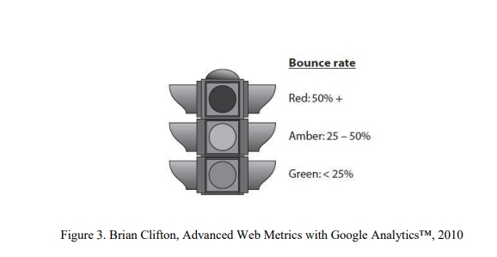

After all, producing and maintaining content is costly. If the visitors of a site aren’t interested in reading more than one page of the specific site, this maybe because of irrelevant content on the website. Medium bounce rate pages (amber, 25-50%) constitute hopefully the majority of a website’s pages. Thus, they may not be considered as the priority of pages that will be optimized for improvement.

Low bounce rate pages (green, smaller than 25%), despite having a good performance, shouldn’t be ignored, either. These pages can be targeted for new promotions, major news updates, or important announcements, since they are the ones with the largest traction among the website’s visitors. According to Compass Blog’s “Ecommerce Bounce Rates – 2016 Benchmarks”, the average bounce rate in ecommerce is 60%, with the industry’s top performers operating at a 36% or lower bounce rate. High bounce rates, though, don’t indicate failure in all cases.

For instance, a page of an ecommerce site that includes only contact information, or even leads to a call to a telephone hotline, is expected to have a much higher bounce rate. Finally, according to the Ecommerce Benchmark & Retail Report 2016, issued by Ecommerce Europe in association with Ecommerce Foundation, the bounce rate in the Fashion industry is slightly lower than in other industries, and that is 35.52%. Accord- -11- ing to the report, the reason for that may be that people do not know exactly what they are looking for. As a result, people will click through and look for other items.

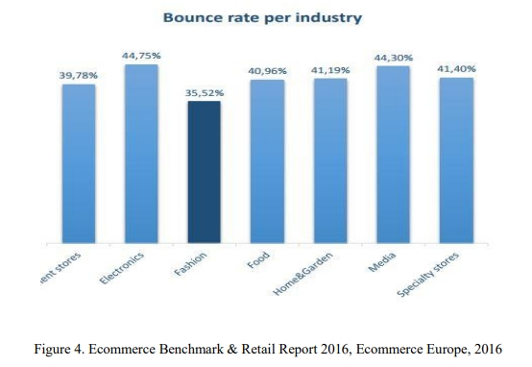

Also, according to the same source, as we see in Figure 5, the Bounce Rate in Greece was averaging on 40.07% in 2016, with Poland being the best performing European country with 33.08%.

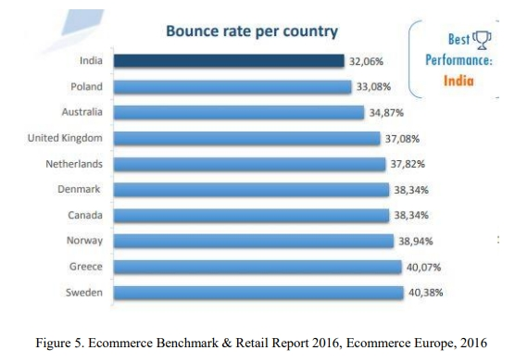

**CHAPTER 3**

**Proposed MethodologY**

In order to design the research, it is necessary to initially identify its goals and create the corresponding research questions. The appropriate methodology is defined by the outcome that the researcher wants to reach. In the present study, once the general purpose and the individual research questions were designated, the methodology instrument that was chosen is the questionnaire. Afterwards, the participants were selected and I proceeded to conduct the research. The implementation of the research was followed by the analysis of the collected data

The proposed methodology for analyzing sales generated through a novel digital marketing approach focused on conversion rate optimization (CRO) in the fashion and beauty e-commerce sectors involves a comprehensive, data-driven process. This methodology will use a combination of quantitative and qualitative metrics to evaluate how effectively the digital marketing efforts translate into sales, customer engagement, and long-term growth. The first step will involve establishing baseline metrics, including current conversion rate, average order value (AOV), customer acquisition cost (CAC), and customer lifetime value (CLV), to create a point of reference for measuring improvements.

To gather these insights, the methodology will incorporate advanced data analytics tools, such as Google Analytics, heat mapping, and machine learning algorithms, to track and analyze customer behavior across multiple digital channels, including the website, social media, email, and paid advertising. Each component of the marketing approach—such as personalized product recommendations, AR try-ons, user-generated content, and mobile optimizations—will be monitored individually and in combination to determine their impact on sales. Attribution modeling will be used to analyze which touchpoints in the customer journey are driving conversions, allowing for a clear view of how each element contributes to overall sales performance.

3.1 **Goal of the Research**

In this chapter I will present the Research I have conducted as part of my thesis, which aimed in studying the opinion of e-shops users/visitors on some main usability factors that were documented in the previous chapter of the dissertation, in order to produce useful conclusions and suggestions for the Conversion Rate Optimization practices of the fashion and beauty e-shops. More specifically, the goals of the survey were to find out: ➢ Which is the most dynamic group for these e-shops ➢ How many buy online ➢ What device they use for connecting online ➢ If they visit fashion and beauty e-shops and through which channel ➢ How they login on e-shops ➢ Their opinion on several usability elements and functions of e-shops.

3.2 **Research Instrument**

The survey was based on a questionnaire, which was developed and executed on the SurveyMonkey platform. SurveyMonkey is an online survey development cloud-based software, that provides to the user many personalization and customization features, regarding the format of the questions (e.g. multiple choice, true false, open-ended, etc), -56- as well as customization features regarding the appearance of the survey (e.g. colors, themes, etc.). Regarding the implementation, it provides the user with the link to the survey, that can be either posted on the user’s website/blog, or even social media pages, or be sent by e-mail. It has the ability to track respondents, so the non-respondents can be recontacted. Finally, it helps the user export the collected data and draw some results charts and graphs, and also has the option to export data into programs like SPSS for more complex analysis. The questionnaire of the survey was originally written and disseminated in Greek, since the greek users are the ones who were the core target audience of the survey, but in the Appendix of the survey it can be found both in the original version (Greek) and in the translated English version. It consisted of 22 closed-ended and structured questions, devided in 6 thematic categories, which are the following: ➢ Demographics ➢ Use of Internet ➢ Use of Fashion & Beauty e-shops ➢ Elements & Functions of the e-shop ➢ Elements & Functions of the Product Page ➢ Check-out. The survey remained open for a period of a month, from November 9 to December 9, with a given completion rate of 94%.

3.3 **Research Sample**

The questionnaire was sent through e-mail and social media platforms to more than 1.000 people. These people include Students of the last two years of all the Master Programs of the International Hellenic University of Thessaloniki, Academic Staff of the University, coworkers from my company, friends, family and others. The dissemination of the questionnaire was done in such way, in order to have as much a diverse sample as possible, both regarding age and their education and employment status. Out of those people who received the questionnaire 349 answered, 66% were Women and 33% Men.

In addition to traditional metrics, the methodology will include A/B testing to optimize the effectiveness of different marketing elements, such as targeted ads, personalized emails, product page layouts, and checkout processes. This will provide insights into which design and content choices yield higher conversion rates, helping to refine the approach continuously. The methodology will also utilize cohort analysis to segment customers by factors such as purchase frequency, average spend, and customer retention, identifying trends and patterns in customer behavior over time.

Further, sentiment analysis on customer reviews and feedback will be integrated to capture qualitative insights, revealing how customers perceive the value and authenticity of the brand’s sustainability and ethical positioning. By combining these quantitative and qualitative findings, the analysis can identify which aspects of the digital marketing approach resonate most with customers, contributing to brand loyalty and future sales growth.

finally, periodic reporting and real-time dashboards will be established to allow for continuous monitoring, and results will be evaluated against the established baseline metrics to assess the overall success of the CRO-focused digital marketing strategy. By following this systematic methodology, e-commerce brands in fashion and beauty can not only optimize current sales performance but also build a scalable framework for sustained, data-driven improvements in conversion rates and customer satisfaction.

**CHAPTER 4**

**Implementation and Result**

In this chapter, I will analyze the data that I have collected through questionnaires. I am going to analyze and present tables and statistics for all of the questions of the questionnaire, based on the answers that were given by the participants of the survey. It was the central phase of the research and provided valuable information on the issue under investigation. At first, I am going to analyze the answers of each question separately, but except from that I have also produced some correlations between questions, using the available tools of the SurveyMonkey platform.

**Results Analysis:**

First of all, starting with the Demographics, as mentioned in the previous Chapter (3.3), the total number of respondents was 349. As can been seen in Chart 1, out of those people, 231 were Women (66.19%) and 118 were Men (33.81%).

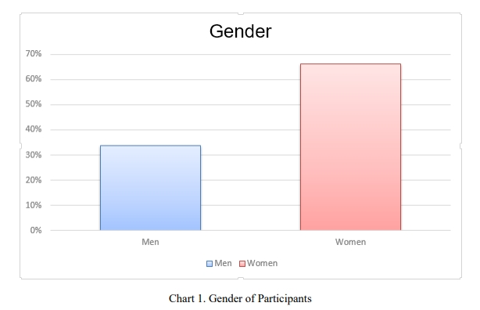

The next question was about the age of the respondents. In chart 2 we can see that the vast majority of the respondents, 199 people, are aged 25-34 (57.02%), while 79 people are aged 15-24 (22.64%), 51 are aged 35-44 (14.61%), 15 are aged 45-54 (4.30%) and, finally, 5 people are aged 55+ (1.43%). As we can see up to that point, a percentage of 94.27% are aged between the ages 15-44, which are the most tech-savvy people.

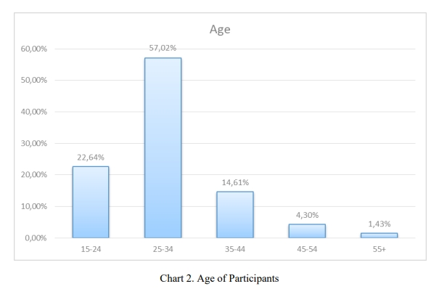

More specifically, the women who took that survey and are aged 25-34 are 122 (Chart 3), 35% of the total number of participants, which points out that they are the most dynamic target group for these industries’ e-shops, with the same aged men being 63 (Chart 4), which is with 18% of the total participants number, the second most attractive target group for these e-shops.

Regarding the frequency of using the Internet, as we can see in the chart 5, 36% said that they use the Internet more than 30 hours a week, 27% said 20 to 30 hours a week, 23% said 10 to 20 hours a week, 11% said 5 to 10 hours a week and 3% said that they use the Internet less than 5 hours a week.

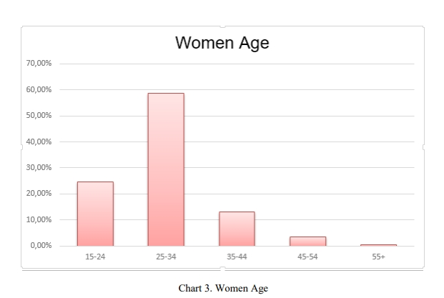

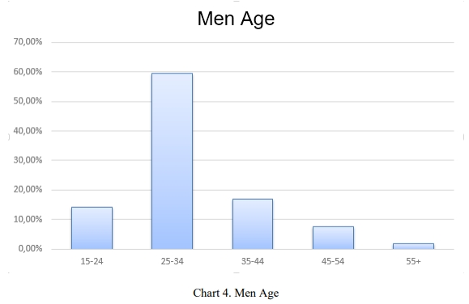

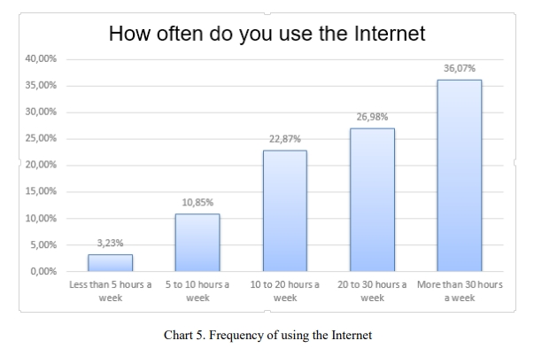

The 4th question, was about the fact of either buying online or not, where an impressive 92% said that they do purchase online, with only 8% answering in a negative way (Chart 6).

This question was the one that acted also as an “eliminating” question, since all those who answered negatively, after pressing the “continue” button to move on, were automatically taken to the exit (Thank You) page. The next question was about the device that they usually use to connect to the Internet, where the available choices were the Desktop/Laptop, the Smartphone and the Tablet. As we see in Chart 7, the mostly used device is the Desktop/Laptop with 90%, followed by the Smartphone that scored at the very important percentage of 45% and the Tablet with 15%.

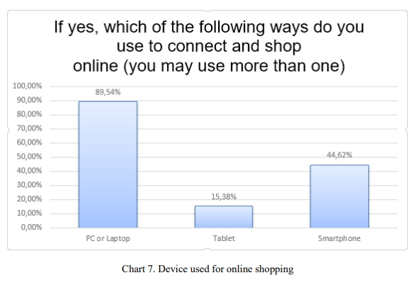

This result leads as to the conclusion that since many users nowadays use mobile devices for their online purchases, the shopping environment for both AndroidOS and iOS must be optimized and have a uniform layout with the one for the Desktops/Laptops, in order for the user to have a more comfortable experience with the e-shop. Next, there was a question regarding the frequency of visiting Fashion and Beauty eshops. The general answers here are very interesting since, as we can also see in the chart below, the percentages are quite scattered. More specifically, we can see in Chart 8, that 25% said that they visit such e-shops less than once a month, while 23% said that they visit them 2-3 times a week, which are quite apart from each other. The rest said at -62- 16% 2-3 times a month, 14% once a week, 12% once a month and almost 10% said every day.

**CHAPTER 5**

**Discussion and Conclusion**

* 1. **Git Hub Link of the Project:** Share the GitHub link
  2. **Limitations:**

The sales analysis of a digital marketing approach aimed at conversion rate optimization (CRO) in the fashion and beauty e-commerce sectors, while comprehensive, faces several limitations. One significant limitation is the complexity of attributing sales to specific marketing efforts. Fashion and beauty consumers interact with brands across multiple channels and devices, which makes it challenging to identify which touchpoints ultimately influence the purchase decision. Even with advanced attribution models, pinpointing the true driver of conversions can be difficult, as customer journeys are often non-linear, and interactions across social media, emails, ads, and websites overlap.

While data analytics tools can track user behavior and conversion metrics, they may not always capture complete or accurate data due to issues such as ad blockers, cookie restrictions, and privacy regulations like GDPR. These limitations can lead to data gaps that make it harder to analyze and optimize digital marketing efforts accurately. Additionally, heavy reliance on quantitative metrics may overlook the qualitative aspects of customer experience and brand perception, which are especially critical in fashion and beauty, where emotional engagement plays a big role in purchasing decisions.

Furthermore, A/B testing and personalization efforts may be constrained by smaller sample sizes or short time frames, particularly for niche brands or seasonal campaigns. This can affect the statistical significance and reliability of the results, potentially leading to misleading conclusions about which marketing tactics are effective. Personalization, while highly effective, also carries a risk of overfitting or alienating certain customer segments, as too narrow a focus on individual behavior can miss broader trends or shift the appeal away from new audiences.

The fast-paced nature of the fashion and beauty industries presents another challenge, as trends evolve rapidly, making it difficult to establish long-term marketing strategies based on short-term CRO analysis. What works during one season or trend cycle may not be as effective in the next, requiring continuous adaptation that may not align with a data-driven analysis framework focused on stability. Finally, limitations in capturing the full impact of sustainability or ethical branding efforts can hinder the analysis, as the value these elements add is often indirect and harder to measure in terms of immediate sales.

Overall, while a data-driven, CRO-focused analysis provides valuable insights, these limitations highlight the importance of a balanced approach that combines quantitative analysis with qualitative understanding and adaptability to navigate the evolving landscape of fashion and beauty e-commerce.

5.3**Future Work:**

Despite the fact that Conversion Rate Optimization is a topic that has been referred to at a significant extent, there is always room for further research and analysis. Especially regarding the CRO that is related with the two sectors which were dealt with in this dissertation, namely the Fashion and the Beauty e-commerce sectors, there is significant space for research.

A suggestion for future work could be for the survey to be taken at a more multicultural sample, for example at a wider European level, possibly conducted by a European institution, in order to find out the differences in the prism through which the citizens of different countries or parts of the continent look upon some usability factors and elements.

For example, it would be useful to see if the citizens of north European countries -80- are more familiarized with the Chat-Bot function than Greek users are, and examine the reasons for that difference. Another element that could be examined through the users’ survey is if their behavior towards e-shops that also have a brick-and-mortar presence is similar to the behavior towards e-shops that are available only online.

A final suggestion would be the combination of various research tools, for example of a survey and some experts’ interviews, and maybe the application of the findings on a model for further validation of the results.

5.3**CONCLUSION:**

In this part of the dissertation we are going to sum up some conclusions that can be reached after the research that has been conducted. First of all, as we saw earlier, the most dynamic target group for Fashion and Beauty e-shops are Women aged 25-34, who are the 35% (Chart 3) of the people who took the survey, with 31% of them (Chart 9) also stating that they visit e-shops of these sectors 2-3 times a week, pointing out once again that they are the group that drives the revenues of these sectors’ e-shops. Additionally, we see that the Search Bar appears to be of very crucial importance to the visitors of e-shops, with more than 50% percent (Chart 17) of the survey’s participants saying that they use it often or very often.

This is a hint for e-shops that the Search Bar should be always available and visible for their visitors, in order to simplify their navigation and enhance their experience throughout to the checkout process.

Another fact that is worth mentioning is the function of the Chat-Bot, which is very much related to the Search Bar, since both of them are there to provide assistance to the users for finding what they are looking for. In contrast with the familiarity that the participants seem to have with the Search Bar function, the same does not apply to their relationship with the Chat-Bot (Live-chat) function, that most of the e-shops nowadays provide to their users.

The results have shown that 1 out of 2 (Chart 18) participants (almost 50%) said that they have never used this function, making it obvious that there is significant room for improvement and further familiarization of Greek users with this very useful function.Also, regarding the product page, it would be useful for e-shops to use 360° Images and videos at a greater extent, since 2 out of 3 (Chart 19) participants (almost 67%) said that they think of these two ways of presenting a product as moderately or extremely useful. Furthermore, there are two facts that can be understood about the psychology of visitors, which also affect their online behavior.

The first fact is related to the answers that where given on the question that was about the product reviews, which can be seen in Chart 20. In this chart we recognized the importance of having user reviews on the product pages, since approximately 70% said that they read them often or very often, but almost the same percentage do not write reviews.

This shows that e-shops should encourage their users more to leave reviews on the products, since it can act as a form of WOM (Word-of-Mouth) marketing practice, as well as a useful feedback for the eshop itself. The second fact related to the online behavior psychology refers to the Social Media.

As we saw in Chart 21, 62% of the participants said that they never post a product on Social Media, but at the same time approximately 31% (Chart 23) said that the number of followers of an e-shop is a very important or an extremely important factor, in order for them to buy from a specific e-shop.

This fact can be interpreted in various ways. On the one hand, it points out the need for e-commerce companies to further incentivize their users to post their products on Social Media, and on the other hand, it indicates that, at some cases, showing the number of social media followers or even the number of Social Media posts of a specific product, can act as a discouraging factor. Finally, the results included also a verification of a major issue that exists in the ecommerce “universe”, which is the phenomenon of Cart Abandonment.

As we saw in Chart 25, a percentage of 97% people said that they have at least once quitted the purchase process, despite the fact that they had already added some products in their carts. Based, also, on the results of the factors that were listed in Chart 26, we can draw several conclusions. First of all, we see that the 2nd most important reason for abandoning the cart is the mandatory creation of a user account.

Taking also into consideration the answers that were given about the preferred way of sign-in (Chart 11), where 76% said they prefer signing in as a Guest instead of 38% of the User account choice, we can assume that providing the option to the users of checking out as guests and not having to create a user account, would definitely help decrease the Cart Abandonment Rate of the e-shop.

Furthermore, judging from the fact that the issues regarding the payment (payment options & safety) were 3rd and 4th in the hierarchy reasons for cart abandonment (Chart 26), and in combination with the answers presented in Chart 23, we can see that it is of vital importance for e-shops to invest even more on providing a safe and trustworthy environment to their users, in order to remove one more obstacle between them and their checkout completion.

Another way to fight the cart abandonment phenomenon could also be introducing some exit pop-ups, which would appear to users who have added products to their cart and are about to exit the site, offering them some special discounts in order to track them back to the checkout funnel. Summing up, I would say that after having researched throughout bibliography, web articles and blogs, best practices that are being followed, and of course having reviewed the survey’s results, I have come to the conclusion that the issue of Conversion Rate Optimization is definitely a never ending process.

Especially for e-shops that operate in the Fashion and Beauty industries that have a very big competition, and whose potential customers are very informed and tech-savvy, the need for optimization is and should be continuous. I hope and believe that my thesis has provided further food for thought to this specialized subject, while there is definitely space for more thorough analysis and even deeper research in the future, as we will see in the final subchapter of the dissertation.

**REFERENCES**

Ash T. (2008). Landing Page Optimization: The Definitive Guide to Testing and Tuning For Conversions. Indianapolis, IN: Wiley Publishing, Inc.

Bertelsen S.M. (2012). Conversion Rate Optimization: Barriers to Adoption. IT University of Copenhagen, Copenhagen, Denmark.

Clifton B. (2010). Advanced Web Metrics with Google Analytics. Indianapolis, IN: Wiley Publishing, Inc.

De Vos & Jansen, Market Research Agency. (n.d.). Visual attention to Online Search Engine Results. Retrieved from:

<http://akademor.webd.pl/download/eyetracking_research.pdf>

Ecommerce Europe. (2016). Ecommerce Benchmark & Retail Report 2016. Retrieved from:

<https://www.ecommerce-europe.eu/app/uploads/2016/06/EcommerceBenchmark-Retail-Report-2016.pdf>

Econsultancy. (2015). Conversion Rate Optimization Report 2015. Retrieved from:

<http://www.ssbchamber.com.au/uploads/Econsultancy-Conversion-RateOptimization-Report-20151.compressed.pdf>

Econsultancy. (2015). Customer Experience Optimization Report. Retrieved from:

<https://www.ensighten.com/wp-content/uploads/2016/12/EconsultancyCustomer-Experience-Optimization-Report.pdf>

Eisenberg B., Eisenberg J. (2006). Waiting For Your Cat to Bark? : Persuading Customers When They Ignore Marketing. Nashville, TN: Thomas Nelson, Inc.

Eisenberg B., Quarto-vonTivadar J., Davis L.T. (2008). Always Be Testing: The Complete Guide to Google™ Website Optimizer. Indianapolis, IN: Wiley Publishing. Inc.